Certification Links & Descriptions

A note to Local Coordinators: Your current coaches may (and should) be checking in to get their certifications up to date. You hold all expiration dates and it will be a combined effort between you and the coach to maintain current certifications. Please copy the information from this template to send to your current coaches when they need certain certifications.
Feel free to Download and Share this document to your coaches and volunteers!
*Local Coordinators: Please attach the General Orientation Presentation to this email.

Certification Links & Descriptions
A couple notes when completing these certifications:
- Be sure to use the same name when completing each certification.
- For record keeping, keep a receipt email (background check or general orientation) or download the certificate (from the protective behaviors or concussion training) for each coach’s records. (Not required)
- Internet is required to complete these trainings.
- At the end of the Class A Form there is an option for the volunteer to print or save answers in PDF. Have volunteers use this option to send their answers onto the Local Coordinator for personal records.

- Fill Out Class A – Please fill out this electronic form for the Class A information. This is the first step of receiving a background check. Special Olympics Ohio will process this into the background check company (First Advantage) on the 1st and 15th (or next business day) of each month. (Yours will be processed on which ever date is next after submission of Class A Form).
  - When processed on the 1st of the 15th (or next business day), you will receive an email from “Special Olympics Ohio Inc.” (we use the email address you submit on your Class A). Please find this email and complete the prompt as soon as possible. *Please see the picture below of what you can expect. (This step includes submitting more sensitive information to the background check company and we have added this step for security purposes)
  - Upon completing the prompt from the Special Olympics Ohio Inc email, you are finished with your portion of the background check.
  - If completed appropriately, your name will be on the next SOOH Master List that is posted on a monthly basis on the 15th of each month for the previous month. (Ex: March 15 is February and previous)
  - This certification must be updated every 3 years.
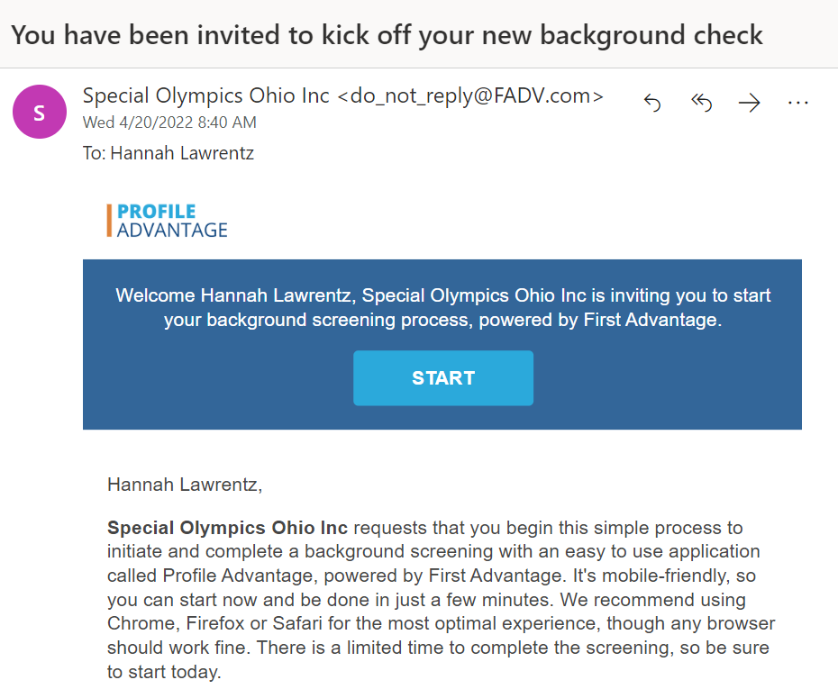

- General Orientation: This certification explains the basics of Special Olympics Ohio, coaching, and an introduction to the many programs we offer as an organization. At the end of the PowerPoint is a link to the General Orientation Quiz where a score of 15/15 is required to be considered complete.
  - Please see the attached PowerPoint Presentation.
  - This is a one-time only certification.

- Protective Behaviors: This course is to be completed on the learning portal. This course ensures all coaches and volunteers behave in an appropriate manner around everyone involved in Special Olympics Ohio. Please see the directions to complete this certification below.
  - This certification must be renewed every 3 years.

- Concussion Training: This course is also completed on the Learning Portal. This course ensures that all coaches and volunteers know how to respond to head injuries or potential concussions and take precautions to reduce injuries. Please see the directions to complete this certification below.
  - This certification must be renewed every 3 years.

Learning Portal Set Up:
- Click on the link here.
- Click “Register.”
- Fill in the Registration Accordingly:
  - Learning Area: Protective Behaviors
  - First, Last, Email, Gender, DOB, Street Address
  - Region: SO-North America
  - Program: Ohio
  - Language
  - Verify and check boxes.
  - Click Register
- A verification email will be sent to the email address you provided. Find this email from OKTA and click on the green button that says “Single Use Special Olympics Account Activation Button”
  - This link will send you to a page to set your password.
- After setting your password, return to the log in page here.
- Log In with the email address you provided and the password you just set.
- On the “My Learning” tab, you will find the 2 certifications you must complete that includes “Protective Behaviors” and “Heads Up Coaches Concussions in Youth Sports.”
- Please complete the entire single module under Protective Behaviors and all 3 modules under the Heads Up Coaches Concussions in Youth Sports.
- Upon completion of the courses, the results will be automatically generated to a list your Local Coordinator will have for record.
*Tip: At the end of each certification, you will have the option to download the certificate of completion. If you save this and there is a discrepancy, the certificate is proof that you completed the certification.

After you have fully completed all of the certifications above, you will be considered a Sport Assistant!

